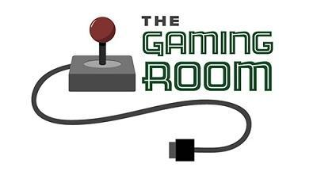

# Draw It or Lose It

# **CS 230 Project Software Design Template**

Version 1.0

## Table of Contents

**CS 230 Project Software Design Template**1

**Table of Contents**2

**Document Revision History**2

**Executive Summary**3

**Design Constraints**3

**System Architecture View**3

**Domain Model**3

**Evaluation**3

**Recommendations**5

## Document Revision History

|  |  |  |  |
| --- | --- | --- | --- |
| Version | Date | Author | Comments |
| 1.0 | 05/23/2021 | Tony Ocasio | Address Software Design problems and other related information |

**Instructions**

Fill in all bracketed information on page one (the cover page), in the Document Revision History table, and below each header. Under each header, remove the bracketed prompt and write your own paragraph response covering the indicated information.

## Executive Summary

Draw It or Lose It is a game that is based on the TV show, Win, Lose, or Draw. Currently the software design problem is that the game is based on android exclusively. The game would need a web-based platform so they can have a game on the computer as well as android.

## Design Constraints

The design constraints that could be a problem would be picking a domain name, since there already could be a website that has the name the company wants. Another constraint that there could be is the need for a modern look which would mean that the team needs to know newer languages in order to make it look clean and fast.

## System Architecture View

Please note: There is nothing required here for these projects, but this section serves as a reminder that describing the system and subsystem architecture present in the application, including physical components or tiers, may be required for other projects. A logical topology of the communication and storage aspects is also necessary to understand the overall architecture and should be provided.

## Domain Model

The UML class diagram below explains the relationships between each class for the project. The classes: Game, Team, and Player all inherit the same attributes from the Entity class along with their own specific attributes. Along with the attributes, they also inherit the methods that Entity has. Game, Team, Player and Entity all have an object-oriented programming principle since each of these are objects and have methods for each class. The GameService class has a 0 to many relation with the Game class meaning more than one can exist at once. Along with the other classes, they all have private attributes and public methods but the GameService class has a private constructor which only the GameService class can use.

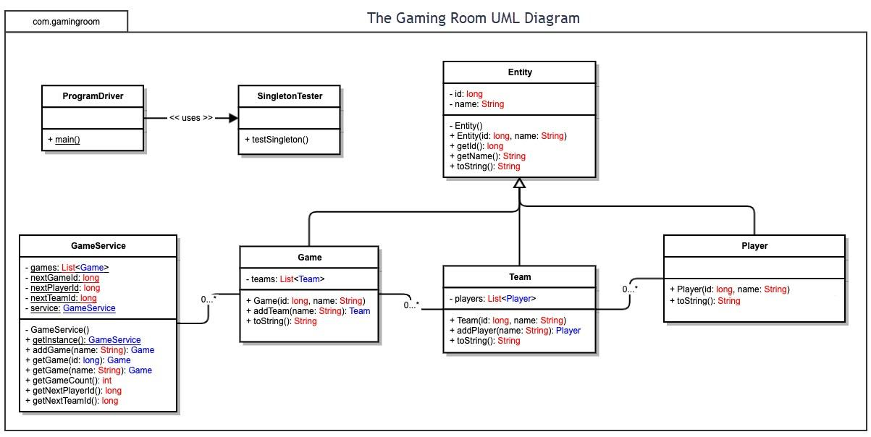

## Evaluation

Using your experience to evaluate the characteristics, advantages, and weaknesses of each operating platform (Linux, Mac, and Windows) as well as mobile devices, consider the requirements outlined below and articulate your findings for each. As you complete the table, keep in mind your client’s requirements and look at the situation holistically, as it all has to work together.

In each cell, remove the bracketed prompt and write your own paragraph response covering the indicated information.

|  |  |  |  |  |
| --- | --- | --- | --- | --- |
| **Development Requirements** | **Mac** | **Linux** | **Windows** | **Mobile Devices** |
| **Server Side** | Mac does have a server-based deployment. Costs for running the server starts at 19.99 | Cheaper than Windows and Mac. More difficult to use. Similar to Mac OS for the terminal. | Could be expensive or cheap. Easy to use. Wider variety of software that could be used. Windows uses Command Prompt vs terminal. | Could be cheap or expensive. Android or iOS which is very different. More difficult creating a web friendly view on a mobile device. |
| **Client Side** | Average respond time for users. Some skill is needed in order to use it. It is more expensive for users due to the price of Macs. | Longer wait time for support. Very complicated to use for an average user. | Short wait time for support. Easy to use even for new users. Still could be cheap or expensive based on the type of system. | Long wait time for support. Multiple OS’ causes problems to be more challenging to solve. |
| **Development Tools** | Mac uses languages like Python, Java, Javascript, CSS, HTML, C++ and some others. The tools that they have are similar to the other OS’ but they also have XCode. | Uses languages like Python, Java, Javascript, HTML, CSS but mainly uses C++. Development tools are Visual Studio and the terminal. | Multiple languages like Mac and Linux plus a lot more. Development tools are Visual Studio, Atom, and the command prompt. | The most popular language is Java and Python. They also use HTML and Javascript. |

## Recommendations

Analyze the characteristics of and techniques specific to various systems architectures and make a recommendation to The Gaming Room. Specifically, address the following:

1. **Operating Platform**: An appropriate operating (server) platform that I would recommend to allow The Gaming Room to expand Draw It or Lose it would be to use the Synology DiskStation DS220j server workstation.
2. **Operating Systems Architectures**: The architecture of the Synology DiskStation DS220j is a 64 bit, quad core processor which is clocked at 1.4 GHz.
3. **Storage Management**: For storage, the workstation has 2 large form factor bays for hard drives to store all of the pictures needed for the game. The company would benefit by using two, 4TB harddrives (or more depending on how many pictures there are) which would provide a sufficient amount of storage for all of the data that they would need to store.
4. **Memory Management**: The workstation uses 512 MB of DDR4 ram which would be sufficient for sending and receiving the data. Although 512 MB of ram is not a lot, it is enough to send and receive the data that the Gaming Room would use. If they need to upgrade the memory to faster or more memory, it has the option to expand it and add more ram.
5. **Distributed Systems and Networks**: Since the Synology DiskStation DS220j is mainly used for storage, sending and receiving files, it could be accessed from any operating system such as Mac, Windows, or Linux. The workstation depends on how much memory, storage and the speed of the network so there are no restrictions based on the operating system.
6. **Security**: For security, the workstation could have a password and encryption on the files so no one could access it without having that information. The server would be able to handle it because there are no strains on the system besides sending the files to the players. They could also set it up to where only people who have admin privileges could access the workstation.